Exp. 5. Band Structure Simulation for Graphene and CNTs using NanoHub
Aim: To simulate the band structure of nanowire for various materials.

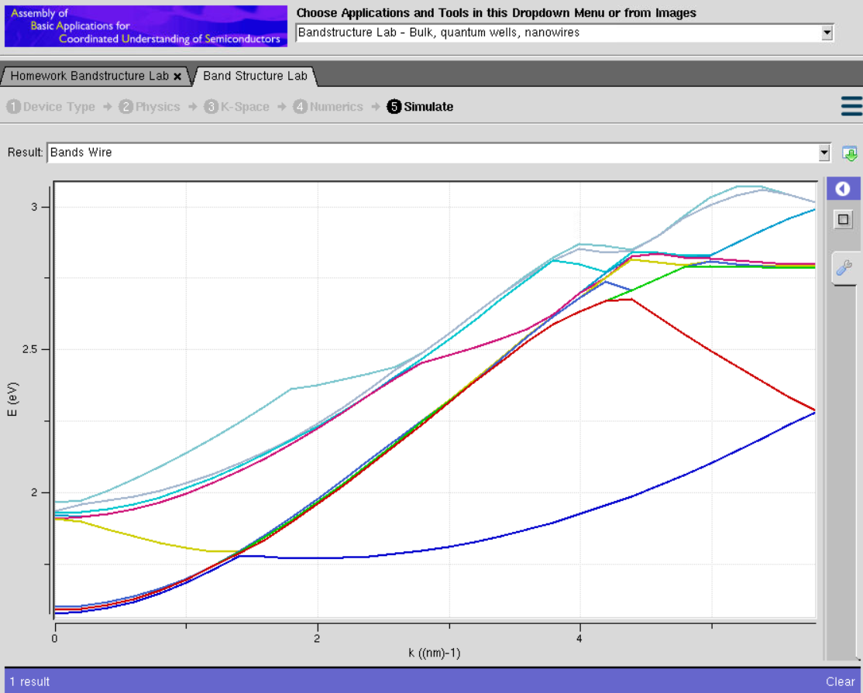

Case Study 1: Simulate the band-structure of InAs circular nanowire
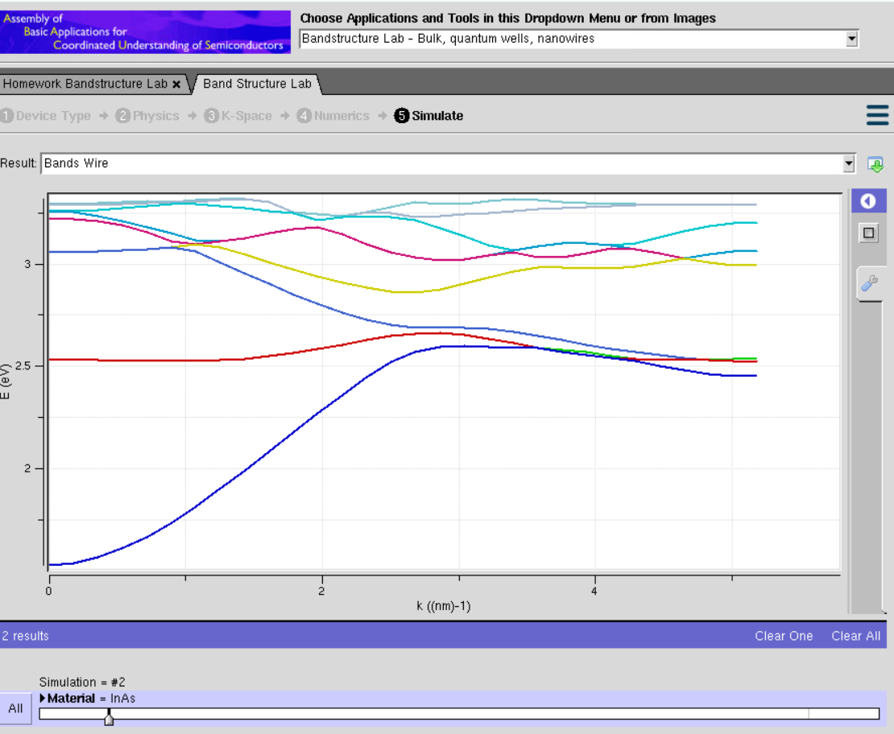
Observations
- The band structure consists of several discrete energy bands due to strong quantum confinement in the circular nanowire.
- The conduction and valence bands remain well separated, indicating the presence of a finite band gap.
- Energy bands exhibit noticeable curvature with increasing wave vector (k), showing the dispersive nature of charge carriers.
- The lowest conduction subband changes smoothly with k, indicating high electron mobility in the InAs nanowire.

Case Study 2: Simulate the band-structure of AlGaAs circular nanowire
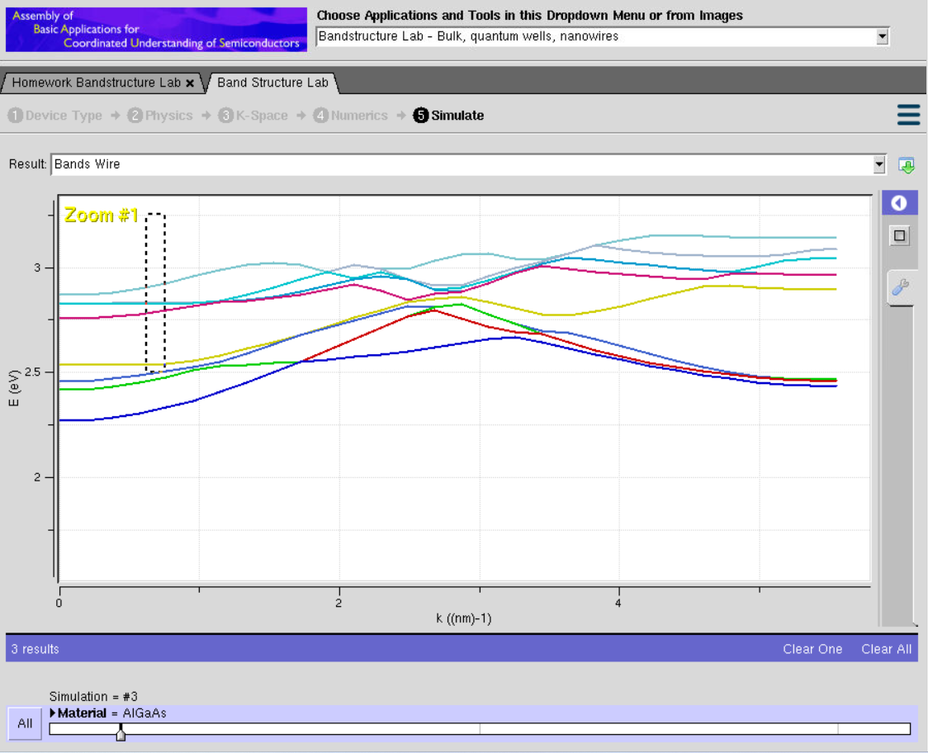

Observations
- Multiple quantized energy bands are observed due to confinement within the nanowire.
- Compared to InAs, the energy bands are located at relatively higher energies, indicating a larger band gap.
- The conduction band is flatter over several k-values, suggesting a larger effective mass and comparatively lower carrier mobility.
- Band dispersion is less pronounced than in InAs, indicating stronger carrier confinement
Conclusion
The NanoHub simulations successfully demonstrate the band structure characteristics of circular nanowires made from different semiconductor materials. Both InAs and AlGaAs exhibit quantized energy bands as a result of nanoscale confinement. InAs shows greater band dispersion, a smaller band gap, and higher electron mobility, making it suitable for high-speed electronic and infrared devices. In contrast, AlGaAs exhibits a larger band gap, stronger carrier confinement, and lower band dispersion, making it well suited for optoelectronic, photonic, and high-temperature applications.

Exp. 6. Demonstration of Quantum Tunneling
Aim: To learn the demonstration of Quantum Tunneling is analysed and the key learning points areobserved using nano hub simulation tool

Case study 1 : Analysis the transmission co-efficient Vs Energy characteristics on refined grid
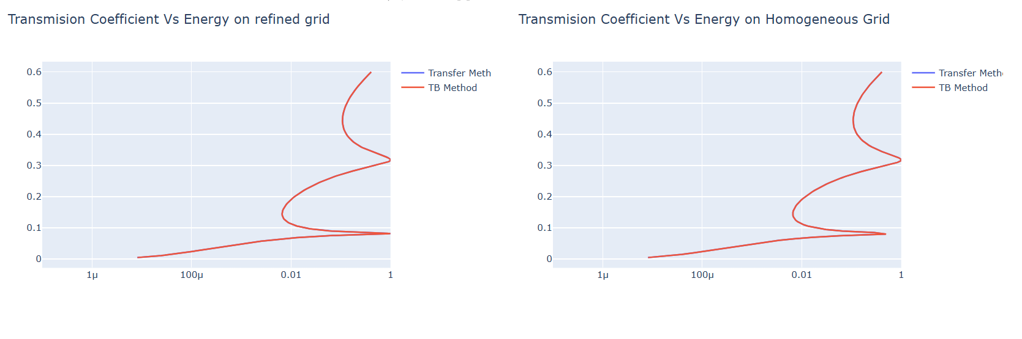

Observations:
- The transmission coefficient is very low at lower energy values, indicating that very few electrons tunnel through the potential barrier.
- As the particle energy increases, the transmission coefficient gradually increases.
- Sharp variations (resonance peaks) are observed at certain energy levels, indicating enhanced tunneling probability.
- The refined grid provides smooth and accurate curves, clearly showing the resonance behavior.
- The results obtained from the Transfer Matrix Method and Tight-Binding (TB) Method almost overlap, confirming good agreement between both simulation methods.

Case study 2 : Analysis the Reflection co-efficient Vs Energy on Homogeneous Grid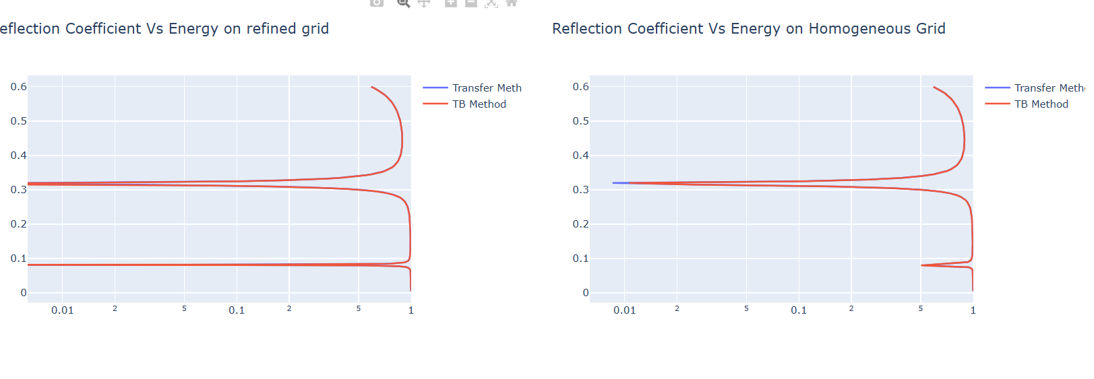

Observations:
- The reflection coefficient is close to one at lower energy values, indicating that most electrons are reflected by the barrier.
- As the energy increases, the reflection coefficient gradually decreases due to increased tunneling probability.
- At resonance energies, sharp dips are observed in the reflection coefficient, corresponding to peaks in the transmission coefficient.
- The homogeneous grid produces a smooth reflection curve with consistent numerical behavior.
- The Transfer Matrix Method and Tight-Binding Method produce nearly identical results, demonstrating the accuracy of both approaches.

Conclusion
- The NanoHub simulation successfully demonstrates the concept of quantum tunneling.
- The transmission coefficient increases with increasing particle energy, while the reflection coefficient decreases accordingly.
- Resonance effects are clearly visible, where electrons tunnel through the barrier with high probability at specific energy levels.
- The close agreement between the Transfer Matrix Method and Tight-Binding Method validates the correctness and reliability of the simulation.
- Overall, the experiment confirms the fundamental principle of quantum mechanics that particles can tunnel through a potential barrier even when their energy is lower than the barrier height, illustrating the wave nature of electrons.

Exp. 7. MOSFET Scaling Analysis and Subthreshold Swing Calculation using NanoHub
Aim: To study the current-voltage characteristics and transconductance efficiency of a single-gateMOSFET using the NanoHUB FetToy Simulator.
Case 1: Increase in VG :
● Observation: As VG increases, the drain current (ID ) also increases exponentiallydue to the MOSFET entering the saturation region earlier.

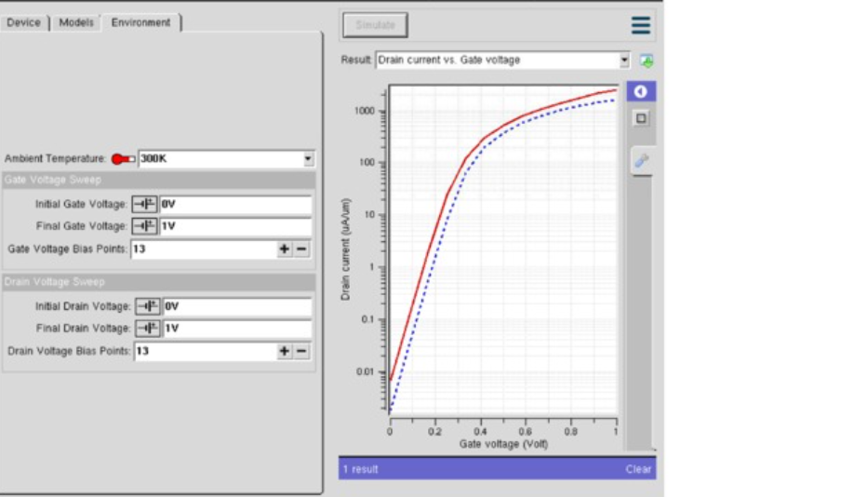
Observations:
- As the gate voltage (VG) increases, the drain current (ID) increases exponentially in the subthreshold region.
- Once the threshold voltage (VTH) is reached, the MOSFET turns ON and the drain current increases rapidly.
- A higher gate voltage enhances the inversion layer, allowing more charge carriers to flow through the channel.
- The device enters the saturation region at lower drain voltages as VG increases.

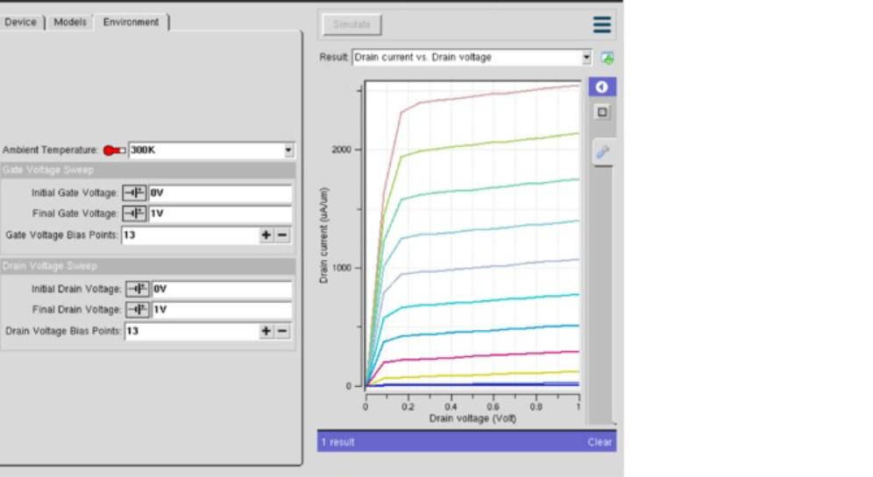

Case 2: Variation in VD :
● Observation: Drain current (ID ) saturates for higher VD at a fixed VG

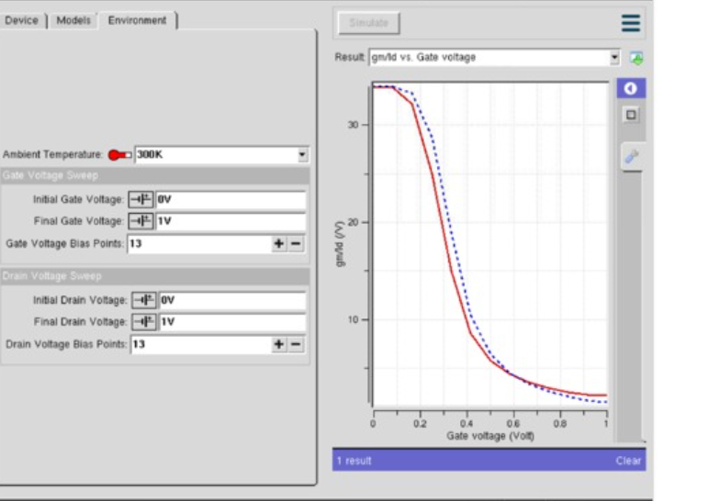

Observations:
- At a fixed gate voltage (VG), the drain current (ID) increases with increasing drain voltage (VD) in the linear region.
- Beyond the saturation voltage, the drain current becomes nearly constant, indicating saturation operation.
- Further increase in VD causes only a slight increase in ID due to channel length modulation.
- The saturation current is mainly controlled by the applied gate voltage rather than the drain voltage.

Conclusion The NanoHub simulation successfully demonstrates the electrical characteristics of a scaled MOSFET.
- Increasing the gate voltage (VG) causes a significant increase in the drain current (ID) due to stronger channel formation.
- The drain current exhibits exponential behavior in the subthreshold region and increases rapidly after the threshold voltage is reached.
- Increasing the drain voltage (VD) increases the drain current initially, after which it reaches the saturation region where the current remains nearly constant.
- The simulation clearly distinguishes the cut-off, linear, and saturation operating regions of the MOSFET

